**Team name: __________________**

**Your name & role: _________________**

**Myth #1**

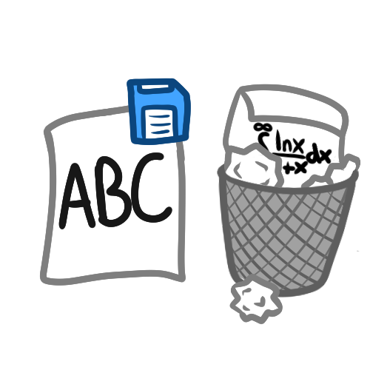The easier that something is to learn, the easier it will be to remember.

**Time to Investigate!**

Read the following abstract. Circle any words that you do not know and underline any key points. After you have finished reading, discuss the questions on your worksheet as a group.

**Fortune Favors the Bold (and the Italicized): Effects of Disfluency on Educational Outcomes**

Diemand-Yauman, C., Oppenheimer, D. M., & Vaughan, E. B. (2011). Fortune favors the bold (and the italicized): Effects of disfluency on educational outcomes. *Cognition*, *118*(1), 111–115. <https://doi.org/10.1016/j.cognition.2010.09.012>

**Abstract**

Research has shown that disfluency – the metacognitive experience of difficulty associated with a cognitive task – engenders deeper processing. Since deeper processing typically leads to better retention, this paper examined whether decreasing perceptual fluency of educational materials would improve retention. Study 1 found that harder to read fonts led to increased retention in a controlled laboratory setting. Study 2 extended this finding to real-world classroom environments. It appears as though perceptual disfluency can function as a desirable difficulty in education. Implications and caveats are discussed.

**Team name: __________________**

**Your name & role: _______________**

**Myth #2**

Opposites attract: We tend to form relationships with people who are different from us more often than those who are similar.

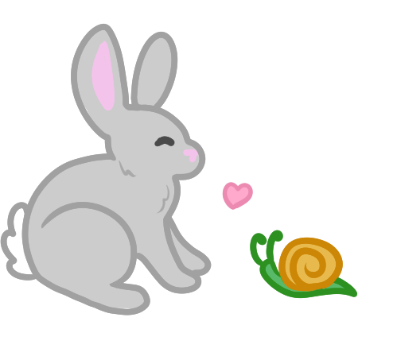

**Time to Investigate!**

Read the following abstract. Circle any words that you do not know and underline any key points. After you have finished reading, discuss the questions on your worksheet as a group.

**Birds of a Feather Do Flock Together: Behavior-Based Personality-Assessment Method Reveals Personality Similarity Among Couples and Friends**

Youyou, W., Stillwell, D., Schwartz, H. A., & Kosinski, M. (2017). Birds of a Feather Do Flock Together. *Psychological Science*, 28(3), 276–284. <https://doi.org/10.1177/0956797616678187>

**Abstract**

Friends and spouses tend to be similar in a broad range of characteristics, such as age, educational level, race, religion, attitudes, and general intelligence. Surprisingly, little evidence has been found for similarity in personality—one of the most fundamental psychological constructs. We argue that the lack of evidence for personality similarity stems from the tendency of individuals to make personality judgments relative to a salient comparison group, rather than in absolute terms (i.e., the *reference-group effect*), when responding to the self-report and peer-report questionnaires commonly used in personality research. We employed two behavior-based personality measures to circumvent the reference-group effect. The results based on large samples provide evidence for personality similarity between romantic partners (*n* = 1,101; *r*s = .20–.47) and between friends (*n* = 46,483; *r*s = .12–.31). We discuss the practical and methodological implications of the findings.

**Team name: ________________**

**Your name & role: _______________**

**Myth #3**

Our memories are like video cameras that record and replay events just as they happened.

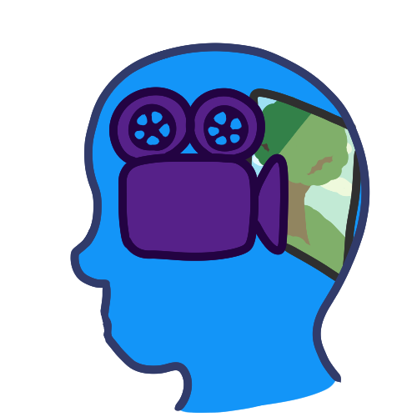

**Time to Investigate!**

Read the following abstract. Circle any words that you do not know and underline any key points. After you have finished reading, discuss the questions on your worksheet as a group.

**Memory blindness: Altered memory reports lead to distortion in eyewitness memory**

Cochran, K.J., Greenspan, R.L., Bogart, D.F. et al. Memory blindness: Altered memory reports lead to distortion in eyewitness memory. *Memory and Cognition*, 44, 717–726 (2016). <https://doi.org/10.3758/s13421-016-0594-y>

**Abstract**

Choice blindness refers to the finding that people can often be misled about their own self-reported choices. However, little research has investigated the more long-term effects of choice blindness. We examined whether people would detect alterations to their own memory reports, and whether such alterations could influence participants’ memories. Participants viewed slideshows depicting crimes, and then either reported their memories for episodic details of the event (Exp. 1) or identified a suspect from a lineup (Exp. 2). Then we exposed participants to manipulated versions of their memory reports, and later tested their memories a second time. The results indicated that the majority of participants failed to detect the misinformation, and that exposing witnesses to misleading versions of their own memory reports caused their memories to change to be consistent with those reports. These experiments have implications for eyewitness memory.

**Team name: ________________**

**Your name & role: _______________**

**Myth #4**

Listening to music from classical composers such as Mozart makes babies and young children smarter.

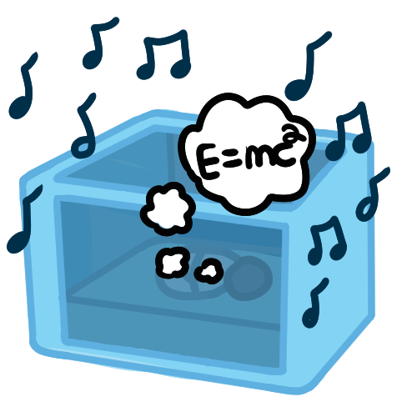

**Time to Investigate!**

Read the following abstract. Circle any words that you do not know and underline any key points. After you have finished reading, discuss the questions on your worksheet as a group.

**Two Randomized Trials Provide No Consistent Evidence for Nonmusical Cognitive Benefits of Brief Preschool Music Enrichment**

Mehr, S. A., Schachner, A., Katz, R. C., & Spelke, E. S. (2013). Two Randomized Trials Provide No Consistent Evidence for Nonmusical Cognitive Benefits of Brief Preschool Music Enrichment. *PLoS ONE*, 8(12), e82007. <https://doi.org/10.1371/journal.pone.0082007>

**Abstract**

Young children regularly engage in musical activities, but the effects of early music education on children's cognitive development are unknown. While some studies have found associations between musical training in childhood and later nonmusical cognitive outcomes, few randomized controlled trials (RCTs) have been employed to assess causal effects of music lessons on child cognition and no clear pattern of results has emerged. We conducted two RCTs with preschool children investigating the cognitive effects of a brief series of music classes, as compared to a similar but non-musical form of arts instruction (visual arts classes, Experiment 1) or to a no-treatment control (Experiment 2). Consistent with typical preschool arts enrichment programs, parents attended classes with their children, participating in a variety of developmentally appropriate arts activities. After six weeks of class, we assessed children's skills in four distinct cognitive areas in which older arts-trained students have been reported to excel: spatial-navigational reasoning, visual form analysis, numerical discrimination, and receptive vocabulary. We initially found that children from the music class showed greater spatial-navigational ability than did children from the visual arts class, while children from the visual arts class showed greater visual form analysis ability than children from the music class (Experiment 1). However, a partial replication attempt comparing music training to a no-treatment control failed to confirm these findings (Experiment 2), and the combined results of the two experiments were negative: overall, children provided with music classes performed no better than those with visual arts or no classes on any assessment. Our findings underscore the need for replication in RCTs, and suggest caution in interpreting the positive findings from past studies of cognitive effects of music instruction.



** Mythbusters**



1. In your own words, what does the myth that you were assigned mean? Do you believe this myth?
2. Were there any words in the abstract that you did not understand? If so, write them below.
3. What were the major findings or takeaways from the abstract that you read?
4. Do the findings reported in this abstract support your myth? Why or why not?
5. Was there a particular statement that led you to this conclusion? Do others in the group agree?